Aquatic Invasive Species (AIS)
Information for
Wabana Chain of Lakes
Resorts and Campgrounds

Zebra mussel (Dreissena polymorpha)
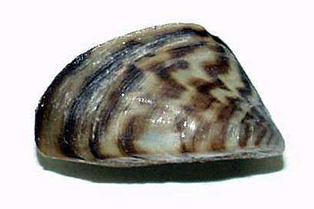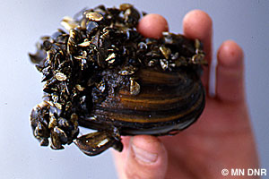
Photos courtesy of MN DNR & Minnesota Aquatic Invasive Species Research Center, U of M

AIS Contacts – (call for help identifying suspected AIS)
AIS Hotline (AIS Coordinator Bill Grantges, Itasca County) 218-256-4243
MN DNR (AIS Specialist Rich Rezenka) 218-328-8821
AIS Detector (WCOLA member Jean Panchyshyn) 952-250-6690

May 2018
WCOLA

May 2018

To: Resort Owners and Campgrounds on the Wabana Chain of Lakes
From: WCOLA Water Quality Team
Re: Aquatic Invasive Species (AIS)
The Wabana Chain of Lakes Association’s Water Quality Team has worked on several projects to support maintaining the water quality on our lakes. One area relates to how we can all take action to help prevent Aquatic Invasive Species (AIS) from entering our lakes. We thank you for helping and are providing the following information to assist you in your efforts.

AIS can have a negative impact on tourism and the businesses – like you - that support the recreational opportunities on our lakes. Resorts and campgrounds can help to keep our waters free from AIS in the following ways:

- Provide guests with AIS prevention information prior to their visit (sample letter attached and available for download & personalization on the DNR web site at: https://www.dnr.state.mn.us/invasives/resorts_and_campgrounds.html
- Educate guests on how they can help stop AIS from entering the lakes they have come to enjoy. AIS Identification information is included in this packet for you to post at your business and/or make available to your guests.
- Post signs on how to stop the spread of AIS at water access points. Free signs are available at the DNR web site noted in #1 above. Examples are attached.
- Learn how to check watercraft for AIS. See attached on Inspecting Boats.

Training is available for anyone interested in preventing the spread of AIS. Contact Itasca County AIS Coordinator Bill Grantges, 218-256-4243, or email coordinator@itascaais.info, to ask about training opportunities.

Aquatic Invasive Species To Look Out For:

Five species that have been identified to be most concerning in Itasca County include two invertebrates: Zebra Mussels and Spiny Waterflea; and three Plants: Starry Stonewart, Eurasian Watermilfoil, and Curly-leaf Pondweed.

Following are photos of the five invasives to be on the look out for. If you think you might have found one of the following, or some other invasive, take a photo and note the location found. Contact one of the following for AIS identification:
- DNR AIS Specialist Rich Rezenka at 218-328-8821 or Richard.rezanka@state.mn.us
- Itasca County AIS Coordinator Bill Grantges, 218-256-4243 or coordinator@itascaais.info
- WCOLA member/AIS Detector, Jean Panchyshyn, 952-250-6690 or tsp.jmp@gmail.com

The following AIS photos can be shared with your guests, and individual ID cards are also enclosed. Additional copies of ID cards can be ordered from the DNR (order form attached).
Following are photos of five Aquatic Invasive Species to be on the look out for. If you think you might have found one of the following, take a photo and note the location found. Report any suspected AIS to management.

Spiny Waterflea, photo credit: Gary Montz, 144, Bugwood.org

Size: ¼” – 5/8”
Often found clumped on fishing line
Has black eye spots
Has 1-4 pairs of barbs on long spiny tail
Looks similar to: Native Predatory zooplankton

Zebra Mussels, photo credit:
United States Geological Survey

Size varies from: 1/5” - 2”
Has zigzag strips; some may be solid tan or brown
Has flat edge and shells form a fairly straight line when closed
Can be found with several clumped onto an object, such a rock, clam, or on docks and boats
Looks similar to: Native snails and mussels

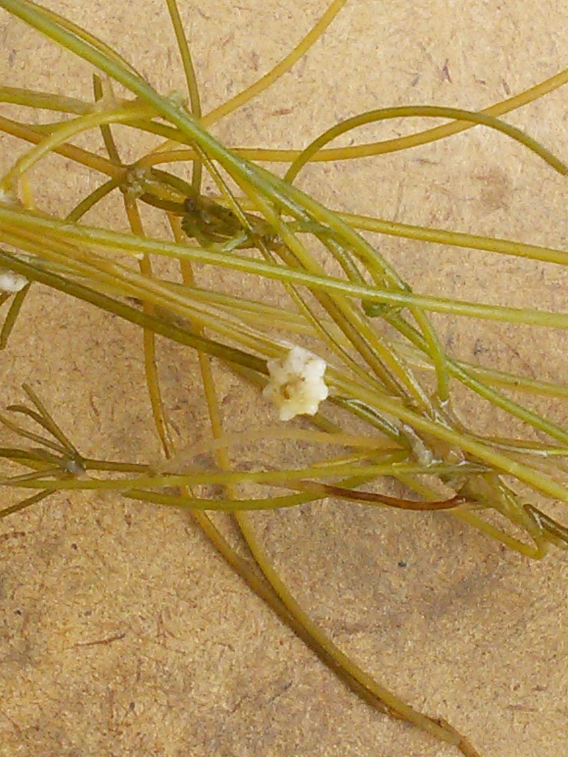
Starry Stonewort, photo credit: Bruce Anspach https://www.eddmaps.org/midwest/distribution/point.cfm?id=4759545

Size: Branchlets can be up to 12” long
Can form small star-shaped bulbils at base of plant
Long, smooth branchlets are attached in whorls of 5 – 8
Forked tips of branchlets are asymmetrical
Small orange spheres (antheridia) may be visible
Found in shallow and calm water near accesses
Looks similar to: Native Muskgrasses and Stoneworts

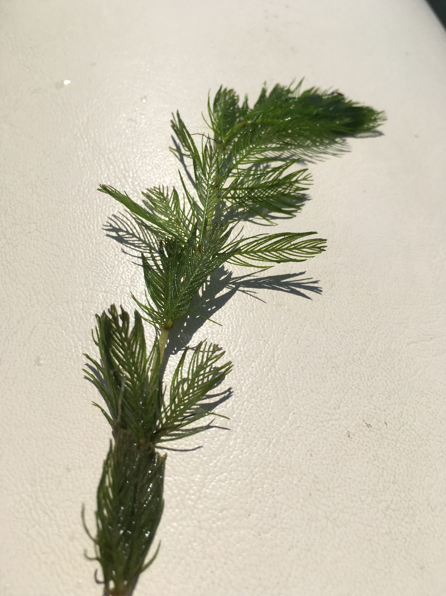
Eurasian Watermilfoil, photo credit: Megan Weber, AIS Extension Educator, U of M

Size: can get to 10 feet long
Leaves are feathery with 4 leaves per whorl
Leaves have central axis with 12 – 20 leaflet pairs
Produce pink and white flowers on spike above the surface
Looks similar to: Native Northern watermilfoil, coontail, bladderworts, white water crowfoot, water marigold

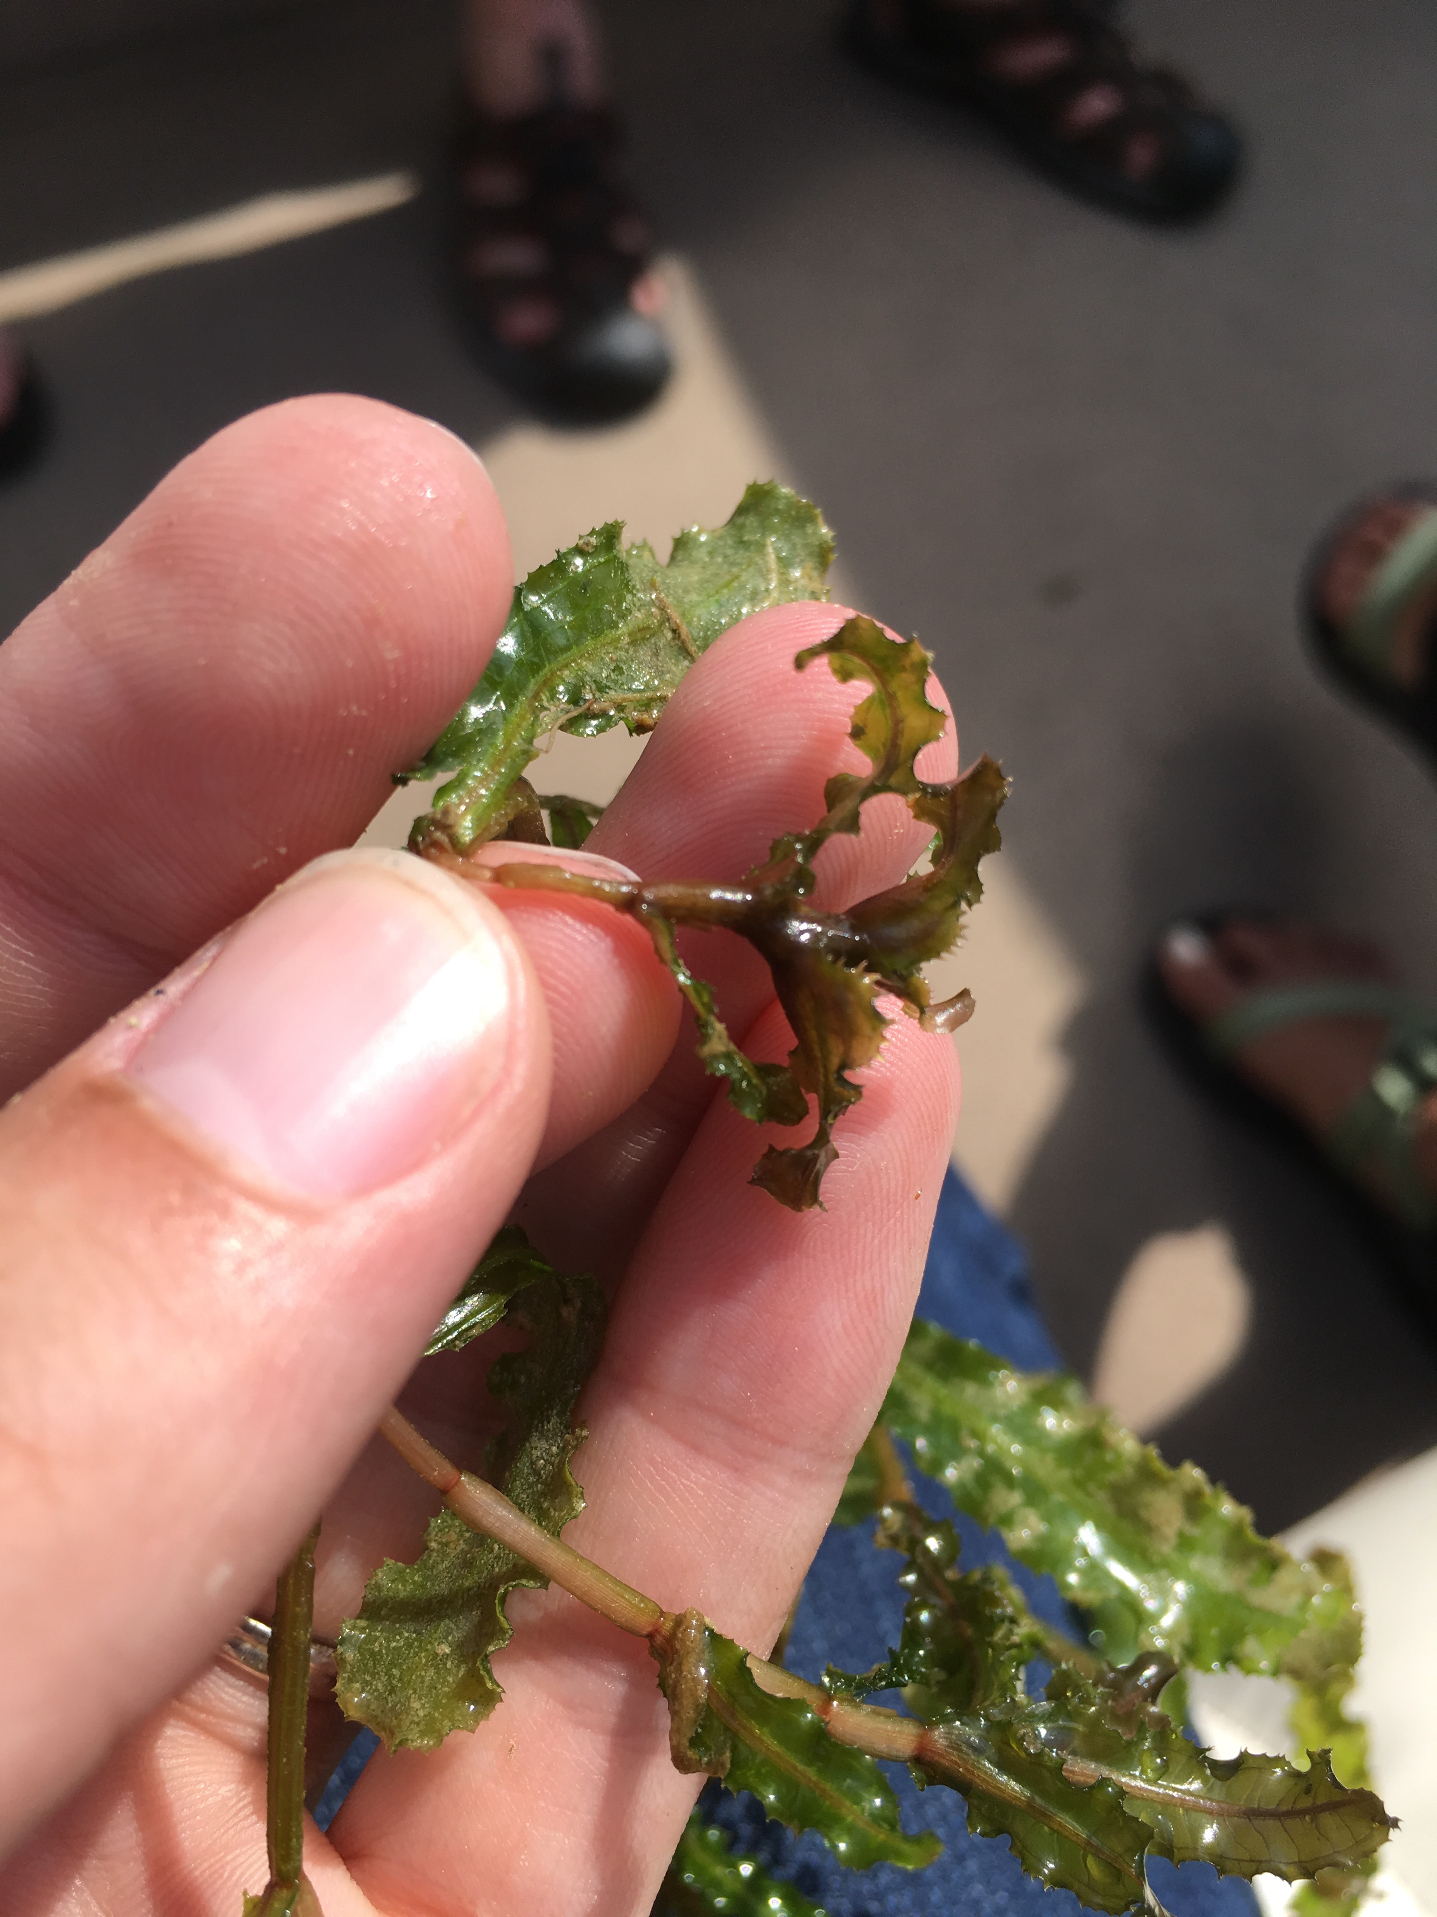
Curly-leaf Pondweed, photo credit: Megan Weber, AIS Extension Educator, U of M

Thin, submerged leaves have small ”teeth” and wavy edges
Produce turions that look like little pinecones
Usually one of first pondweeds to develop in spring and die back mid-summer
Can be found in water up to 15 feet deep
Looks similar to: Native Clasping leaf pondweed

Additional information on AIS is available on the MN DNR website: http://www.dnr.state.mn.us/invasives/index.html, and the University of Minnesota Aquatic Invasive Species Research Center website: https://www.maisrc.umn.edu
Source: Minnesota Aquatic Invasive Species Research Center in partnership with University of Minnesota Extension. (2017). AIS identification guide. Minneapolis, MN: Regents of the University of Minnesota.

WHERE TO GO IF A BOAT NEEDS TO BE CLEANED/WASHED

Itasca County has three mobile decontamination units that are available for free courtesy washes/decontaminations. The schedule and location of the County decontamination units can be found on the Itasca Soil and Water Conservation District web site: https://www.itascaswcd.org/ais-decon-station-locations
The DNR also has decontamination units – check the DNR website for locations:
http://www.dnr.state.mn.us/invasives/watercraft_inspect/courtesydecon.html

INSPECTING BOATS – INSPECT EVERYTHING!

Clean – visible aquatic plants and invasive species off any watercraft and trailers before leaving a water access/ shoreland property.
Drain equipment – boat, ballast tanks, portable bait containers, motor, bilge, livewell & baitwell, before leaving water access/ shoreland property.
Dispose – unwanted bait in the trash. It is illegal to release live bait into the water or to release worms on the ground.
Spray, Rinse and Dry watercraft and equipment before going to another waterbody, especially if your boat has been in the water for more than 24 hours or in a zebra mussel or spiny waterflea infested lake.
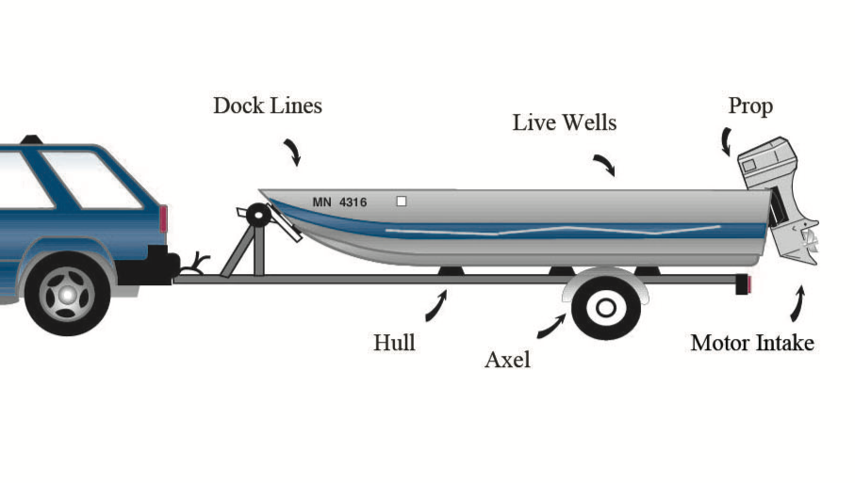
Bilge/
Anchor &
Rollers & Bunks
Trailer

INSPECT OTHER WATERCRAFT
Watercraft Inspection information can be found on the DNR Web site: https://www.dnr.state.mn.us/invasives/preventspread_watercraft.html
The web site noted above has information about other water recreation activities that could spread AIS. Be aware that these items can also be visually inspected for AIS: Personal Watercraft, Sailboats, Paddleboards, Canoes, Kayaks, and Scuba Diving Equipment.
ADDITIONAL INFORMATION FOR RESORTS AND CAMPGROUNDS:

Inspect your Shoreline
Lake Owners can help with early detection of AIS by searching around public water access sites:
- Searches of an area along 100 feet of shoreline on either side of the public water access (a total of 200 feet. Know your property size - do not trespass on private shore land property.
- Go out to a maximum rooting plant depth which is less than 15 feet water depth or 100 feet from shore (whichever is closest) where a rake is used to collect and inspect plants.
- Look for AIS invertebrates attached to hard substrates such as rocks, logs, or other non-invasive invertebrates such as clams (pick up and look at underside of hard substrates. Look at parts of your boat lift and docks that are underwater.

Moving Docks, Boat Lifts, and other Equipment
Lake owners may not be aware of the Minnesota law which states “a boat lift, dock, swim raft, or associated equipment that has been removed from any water body may not be placed in another water body until a minimum of 21 days have passed.” (Minnesota Statutes 84D.10 Subd. 4(f).) After a thorough cleaning, equipment should be kept dry for a minimum of 21 days before placing in the water.

DNR Permit required for transporting docks, lifts and other equipment
If you plan to purchase and/or move a dock, boat lift, swim raft, or other water equipment from one lake or river to another, all visible zebra mussels, faucet snails, and aquatic plants must be removed whether they are dead or alive. A DNR transport authorization permit form is required for individuals who are moving equipment which has had prohibited invasive species and/or plants attached. There is no charge for this permit. If a business provides this service for you, the business would need to get a lake service permit. These forms are available on the DNR website: http://www.dnr.state.mn.us/permits/invasive_species/index.html
If you hire someone to move your equipment, make sure the provider is on the DNR's list of Permitted Service Providers, located online at: https://webapps15.dnr.state.mn.us/ais_business_training/lake_service_provider_permits/public_website_list. (List is organized by county).
To find out if a lake is infested with invasive species, check the DNR Infested Waters List at http://www.dnr.state.mn.us/invasives/ais/infested.html

Source:
http://www3.extension.umn.edu/county/itasca/county-natural-resource-educator/article/information-moving-docks-lifts-and-equipment-itasca-county

http://www.hubbardcolamn.org/uploads/3/4/5/6/34563649/ais_lake_monitoring_early_detection_plan._final_version_._6.17.2016.pdf

ATTACHMENTS AND WEB LINKS:

A) Sample Letter to Provide to Guests (page 7)
online at: https://www.dnr.state.mn.us/invasives/resorts_and_campgrounds.html

B) Water Access Signs (FREE) – examples from DNR (page 8-9)
Online at: https://www.dnr.state.mn.us/invasives/ais/prevention/ais_signs.html

C) DNR Order Form for AIS Educational Materials noted below (MANY FREE) (Page 10-11)
Online at: https://www.dnr.state.mn.us/invasives/ais/outreach.html

D) Educational Materials attached:
Help Protect Minnesota Waters
Stop Aquatic Hitchhikers!
ID Cards for:
- Spiny and Fishhook Waterflea WATCH
- Curly Pondweed WATCH
- Eurasian Watermilfoil WATCH
- Starry Stonewort WATCH
- Faucet Snail WATCH
- Zebra and Quagga Mussel WATCH

E) AIS Identification Guide book available online: https://www.maisrc.umn.edu/ais-idguide

ATTACHMENT A
Dear Visitor to [insert name of resort or campground],

[Your logo here]

Minnesota is renowned for its clean water, good fishing, and remarkable recreational opportunities – and we want to keep it that way for future visitors and future generations.

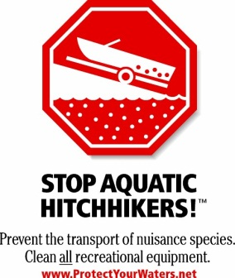
Unfortunately, some invasive species can harm Minnesota’s lakes, rivers, and forests. Aquatic invasive species such as Eurasian watermilfoil, zebra mussel, and spiny waterflea can harm fish habitats and disrupt water recreation activities. These plants, animals, and other unwanted species may “hitch a ride” in water, on boats, in firewood, or on other gear that people move into and around the state.

To help protect Minnesota’s precious water and woodlands and to comply with state law, please take the following precautions before you leave home to visit [insert name of resort or campground] and before transporting watercraft and firewood in the state.

Before traveling to Minnesota every boater must:
- Clean all aquatic plants, zebra mussels, and other prohibited invasive species from boats and trailers. You may not transport aquatic plants or prohibited invasive species in the state, even if they are dead.
- Drain water-related equipment (boat, ballast tanks, portable bait containers, and motor) and
drain bilge, livewell, and baitwell by removing drain plugs. Keep drain plugs out and
water-draining devices open while transporting watercraft. You may not transport water, or arrive at a water access with the drain plug in place, in Minnesota.
- Dispose of unwanted bait, including minnows, leeches, worms and fish parts in the trash. If you want to keep live bait, drain bait containers and refill with bottled or tap water. It is illegal in Minnesota to release bait in the water or to release worms on the ground.
Additional recommended precautions:
Some aquatic invasive species can survive more than two weeks out of water, and they are often small and difficult to see at the access. To remove or kill them, take one or more of the following precautions before moving boats and equipment to another water body, especially after leaving waters infested with zebra mussels or spiny waterfleas:
- Spray with high-pressure water
- Rinse with very hot water (at least 120 degrees F)
- Dry for at least 5 days

Burn local or certified firewood. Rather than bringing firewood to your campground or cabin, buy firewood at the campground or in the town you’ll be visiting. Check the label for “DNR Approved” or the state shield indicating the wood has been certified pest free by the Minnesota Department of Agriculture.

Clean mud, seeds, and plant parts from your OHVs, ATVs, bikes, boots, pets and camping gear before you transport your gear to prevent the spread of weeds and other invasive species.
We are looking forward to your visit. We are sharing this information to help you comply with Minnesota regulations and protect the lakes and forests you come to visit.

For more information, visit www.mndnr.gov/invasives.

[Owner/Manager]

Aquatic Invasive Species Signs at Water Accesses
ATTACHMENT B
Help Stop Aquatic Hitchhikers! signs at water accesses are a key public awareness strategy to help prevent the spread of aquatic invasive species. The DNR provides a limited number of these signs at no cost for lake associations, local governments, and other groups to post at water accesses. You may also print your own signs using the instructions below.

Help Stop Aquatic Hitchhikers! signs
Two sign sizes are available - standard and large. These signs can be used at both public and private water accesses on uninfested and infested waters.
Standard signs are 18" x 24". Generally, two are posted at each access - one at the make-ready area and one in the tie down area.
Large signs are 4' x 3' and are best suited for high-use accesses with 10 or more parking spaces.

Standard Signs  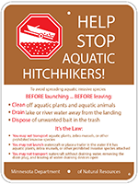  (18" x 24")  Click to enlarge | Large Signs  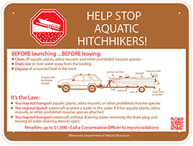  (4' x 3')  Click to enlarge
How to request signs
You may request up to four standard signs, or two standard signs plus two large signs, per calendar year. The DNR has a limited number of signs available and they will be provided to you at no cost. You will be responsible for printing and purchasing any additional signs.
To request signs:
- Receive permission from the water access owners to place signs at the access. You can find ownership information for most accesses using the Recreation Compass tool in LakeFinder. If you would like to place signs at a water access managed by the DNR, contact Nancy Stewart at 651-259-5616.
- Complete an application. PDF Email, mail or fax it to your local invasive species specialist. They will contact you about sign availability.
- Review the Aquatic Invasive Species Sign Manual PDF for installation guidelines. Once you have received the signs, you have sixty days for them to be installed. Sign posts and materials are not provided by the DNR.
For questions on requesting signs, contact your local invasive species specialist.
How to print additional signs
If you would like more signs than the DNR can provide, the sign artwork is available online for you to print on your own. You are responsible for the cost of printing the signs.
To print your own signs:
- Receive permission from the water access owners to place signs at the access. You can find ownership information for most accesses using the Recreation Compass tool in LakeFinder. If you would like to place signs at a water access managed by the DNR, contact Nancy Stewart at 651-259-5616.
- Complete the print authorization form. PDF Provide one copy to the company printing the sign(s). Provide an additional copy to the Minnesota Department of Natural Resources.
  - Mail a copy to: ATTN: AIS Sign Printing, 500 Lafayette Road, St. Paul, MN 55155 or
  - Email an electronic copy to Tina Wolbers .
- Provide your printer with the artwork files. Your printer should have Adobe Illustrator software to use these files. Direct your printer to this website to download the print-ready PDF file(s).
  - Standard Sign
  - Large Sign
- Review the Aquatic Invasive Species Sign Manual PDF for installation guidelines. Sign posts and materials are not provided by the DNR.

Supplementary AIS Signs
Local governments may request the artwork files for supplementary AIS signs. They are responsible for printing and purchasing the signs on their own.

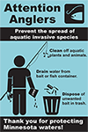  Click to enlarge | 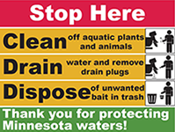  Click to enlarge | Click to enlarge

To print your own signs:
- Receive permission from the water access owners to place signs at the access. You can find ownership information for most accesses using the Recreation Compass tool in LakeFinder. If you would like to place signs at a water access managed by the DNR, contact Nancy Stewart at 651-259-5616.
- Complete the Supplementary AIS Signage Print Authorization Form. PDF Provide one copy to the company printing the sign(s). Send an additional copy to the Minnesota Department of Natural Resources.
  - Mail a copy to: ATTN: AIS Sign Printing, 500 Lafayette Road, St. Paul, MN 55155 or
  - Email an electronic copy to Tina Wolbers .
  - Once the request is approved, the DNR will email the artwork files to you and the printing company. Your printer will need Adobe Illustrator to use the files.
  - Review the Aquatic Invasive Species Sign Manual PDF for installation guidelines. Sign posts and materials are not provided by the DNR.
For questions on printing signs, contact Tina Wolbers at 651-259-5146
