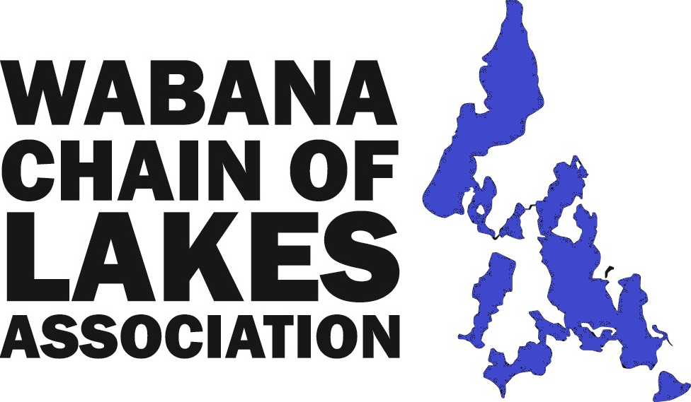  www.WCOLA.org & Facebook  Welcome to  The Wabana Chain of Lakes Association  Who are we?  We are the Wabana Chain of Lakes Association (WCOLA), a group of active, interested, and concerned neighbors and friends. WCOLA is guided by a volunteer Board of Directors, elected by WCOLA members, and acts as an advisory to local, state, and federal governing organizations.  WCOLA is an organization of volunteers who collectively work to build awareness about preserving our chain of lakes – their clarity and quality, their history, and social community so that they may be enjoyed now and in the years to come. We currently have 160+ member households, about 3/5 ^{ths} of our area property owners, but our goal is 100%.  What do we do?  We are dedicated to maintaining and improving the quality of the ecological environment of the lakes and lakeshores in the Wabana Chain of Lakes and the surrounding area in Itasca County, Minnesota.  How do we do that?  ● For over 27 years we have been working with state certified water testing labs and the MPCA, giving us a baseline of data on the health of our waters. The resulting Lake Water Quality Reports are extensive individual reports for Trout, Little Trout, Wabana, Little Wabana, and Bluewater lakes. | The reports contain numerous charts and graphs that explain the lakes chemical make-up and show how our lakes compare to other lakes in the state with respect to water clarity, fisheries, and other key findings. A quick reference is a one-page summary that can be found on the WCOLA website.  ● We partner as volunteers with the Minnesota Pollution Control Agency (MPCA) in reporting Secchi Disk lake clarity reading , ice on, and ice out date recordings. More volunteers are always needed and welcome.  ● WCOLA hosts three major events - June social event, July picnic, and August annual meeting with an educational presentation.  ● We share our stories, family histories, and photos to promote and recognize the history of this area. Some of that local history is on display at the Wabana Town Hall and often in our WCOLA Newsletters and our WCOLA Facebook page.  ● Aquatic Invasive Species (AIS) is a major concern. AIS boat inspections at public accesses will continue to be staffed at least 5 days per week during the open water season. This effort is funded in part by WCOLA’s donation.  Information is provided to the chain of lakes users about AIS issues and preventative actions we all might take. The Water Quality Management Plan for our chain of lakes has been updated is on the WCOLA website. The first AIS Rapid Response Plan for Itasca County has been developed by WCOLA.  ● A Resort Package has been developed and distributed to all the chain’s cabin resorts as well as the two camps.  ● WCOLA has donated funds for the AIS Business Water Summit, the U of M AIS Research Center, and the Itasca County Dive Team. WCOLA has a membership in the Itasca Waters and Itasca Coalition of Lake Associations (ICOLA) organizations.
● WCOLA Board has provided information on septic systems and shoreline management to help residents understand how best to maintain their property. We have distributed an excellent brochure titled “Shoreland Guide to Lake Stewardship” which can be found at www.ItascaWaters.org. We work with and pay attention to how policies and requirements of Federal, State, and Local governments and agencies may impact our chain of lakes.  ● WCOLA does an annual loon count partnering with the DNR. | ● We publish newsletters to keep our members and area residents informed and have a website (www.WCOLA.org) and a Facebook page.  ● We are making a concerted effort to inform all lake owners of events or situations that may be of interest or concern.  ● WCOLA volunteers provide road and Firewise brush cleanup partnering with Itasca County.

Many thanks to all those who have supported us in the past having created and continued with support of the Wabana Chain of Lakes Association.

We invite you, your families, and friends of the Wabana Chain of Lakes to continue as members,
consider becoming members, and volunteering. Working together we continue the efforts of protecting and sustaining the love of our waters and sense of community for now and the years to come.

Jim Olijnek –President Jean Koewler-Treasurer

Louie Gueltzow-Vice President Susan Lick-Secretary

Enclosed is an addressed envelope and membership application to complete. Also note that email is
very much encouraged. WCOLA always welcomes your interests and efforts in any of our activities. You
can find out much more about our organization by going to WCOLA.org.

ˉ ˉ ˉ ˉ ˉ ˉ ˉ ˉ ˉ ˉ ˉ ˉ ˉ ˉ ˉ ˉ ˉ ˉ ˉ ˉ ˉ ˉ ˉ ˉ ˉ ˉ ˉ ˉ ˉ ˉ ˉ ˉ ˉ ˉ ˉ ˉ ˉ ˉ ˉ ˉ ˉ ˉ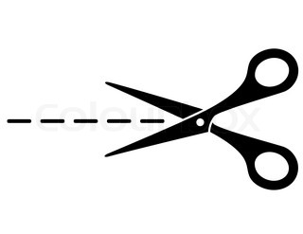 cut here

Wabana Chain of Lakes Association

Dues $30 for those receiving WCOLA communications via email _________________

Dues $35 for those receiving WCOLA newsletters via postal mail _________________

Additional contributions, or Memorials for Lake Protection _________________
(ex. AIS Inspections, Water Quality Sampling, etc.)
Total _________________

Make checks payable to WCOLA and return in the enclosed addressed envelope.

Name: ________________________________________________________________________________

Email address: __________________________________________________________________________

Phone Number: _________________________________________________________________________

Street Address: _________________________________________________________________________

__________________________________________________________________________

If you have a second address please note it and the months that it should be used.

