Wabana Lake Itasca County

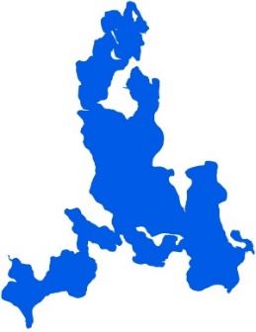
Summary
Wabana Lake is located 13.5 miles north of Grand Rapids, MN in Itasca County. Wabana Lake has three inlets and one outlet, which classify it as a drainage lake. Wabana Lake is part of the Wabana Chain of Lakes Association (WCOLA). The association is involved in activities such as water quality monitoring and education.

There is an improving trend in water quality. Water quality data have been collected on Wabana Lake from 1994-2015. These data show that the lake is oligotrophic (TSI = 36) with very clear water conditions most of the summer and excellent recreational opportunities.

Lake Vitals |  | Long-term Trends
MN Lake ID: | 31-0392-00 | Recommend minimum of 8-10 years of data with 4+ readings per season. Minimum confidence accepted by MPCA is 90%
Ecoregion: | Northern Lakes and Forests
Major Watershed: | Mississippi R. –Grand Rapids
Surface area | 2221 acres
% Littoral area: | 46% | Total Phosphorus: Improving
Max depth: | 115 (ft) 35 (m) | Chlorophyll-a: Improving
Aquatic Invasive Species: | None | Secchi Depth: Improving (1992-2015)

Water Quality Characteristics

Parameters | Site  202 |  | Trophic State Index
Total Phosphorus Mean (ug/L): | 9.2 |  | Trophic State: Oligotrophic (36)
Total Phosphorus Min (ug/L): | <5.0 |  | The figure below shows the minimum and maximum values with the arrows and the mean with the black dot.
Total Phosphorus Max (ug/L): | 20.0
Number of Observations: | 38 | 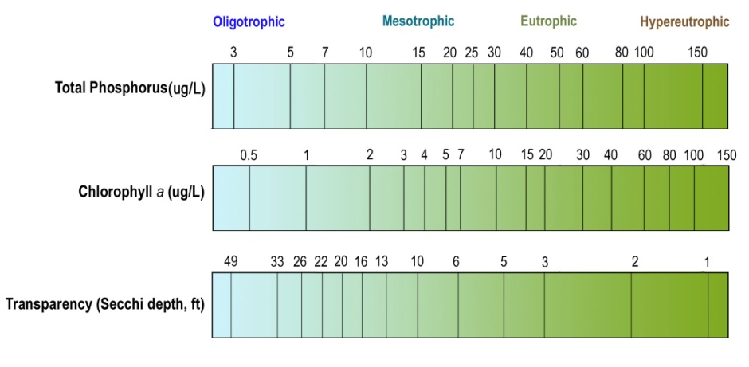
Chlorophyll-a Mean (ug/L): | 2.2
Chlorophyll-a Min (ug/L): | <1
Chlorophyll-a Max (ug/L): | 4.0
Number of Observations: | 33
Secchi Depth Mean (ft): | 19.0
Secchi Depth Min (ft): | 13.0
Secchi Depth Max (ft): | 35.1
Number of Observations: | 121

Historical Data Summary

Monitoring Program | Laboratory | Years
Citizen Lake Monitoring Program | - | 1975-1977, 1988, 1990, 1992-2015
Clean Water Legacy Surface Water Monitoring | - | 2015
Water Quality Inventory of Itasca County Lakes | - | 2001
Lake Monitoring Program | - | 2000
MPCA Lake Monitoring Program Project | - | 1985, 1988, 1991
Itasca County Lake Assessment (+JLCWP) | - | 2001-2002
Bigfork River Watershed Priority Waters Assessment | Natural Resource Research Inst. | 2001-2002
Paleo Lakes | - | 2001-2002
Wabana Chain of Lakes | Itasca Community College | 2010, 2014
Wabana Chain of Lakes | Instrumental Research | 2005, 2008
Wabana Chain of Lakes | MN Chippewa Tribe | 1999, 2003

