Trout Lake Itasca County

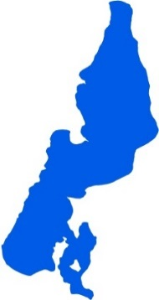
Summary
Trout Lake is located 20 miles north of Grand Rapids, MN in Itasca County. There is no evidence of a water quality trend. Trout Lake has four inlets and one outlet, which classify it as a groundwater drainage lake. There is also a large groundwater interaction component with the lake itself. Water quality data have been collected on Trout Lake since 1992. These data show that the lake is oligotrophic (TSI = 36) with very clear water conditions all summer. In fact, it is so cold and deep that it supports lake trout. Trout Lake is part of the Wabana Chain of Lakes Association (WCOLA). The association is involved in activities such as water quality monitoring and education. Trout Lake itself is mostly located in federally-owned land.

Lake Vitals |  | Long-term Trends
MN Lake ID: | 31-0410-00 | Recommend minimum of 8-10 years of data with 4+ readings per season. Minimum confidence accepted by MPCA is 90%
Ecoregion: | Northern Lakes and Forests
Major Watershed: | Mississippi R. –Grand Rapids
Surface area | 1736 acres
% Littoral area: | 43% | Total Phosphorus: No Trend
Max depth: | 157 (ft) 48 (m) | Chlorophyll-a: No Trend
Aquatic Invasive Species: | None | Secchi Depth: No Trend (1992-2011)

Water Quality Characteristics

Parameters | Site  204 |  | Trophic State Index
Total Phosphorus Mean (ug/L): | 9.5 |  | Trophic State: Oligotrophic (36)
Total Phosphorus Min (ug/L): | <5 |  | The figure below shows the minimum and maximum values with the arrows and the mean with the black dot.
Total Phosphorus Max (ug/L): | 17
Number of Observations: | 37 | 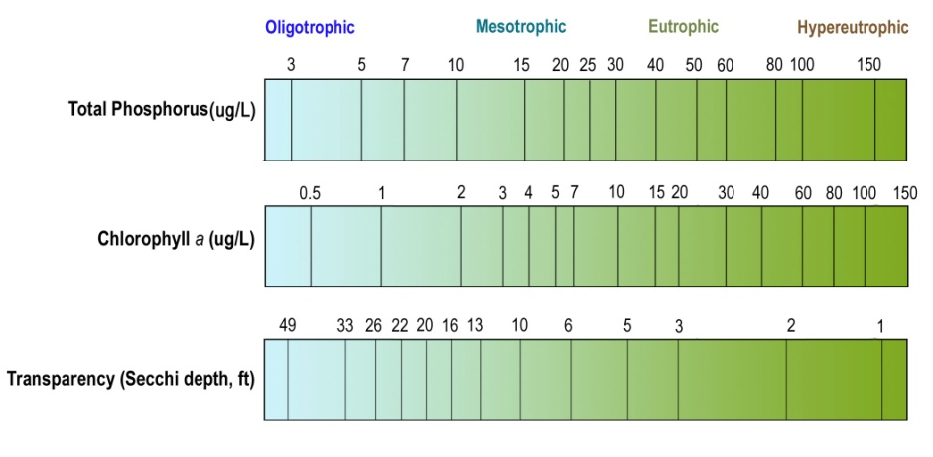
Chlorophyll-a Mean (ug/L): | 1.7
Chlorophyll-a Min (ug/L): | <1
Chlorophyll-a Max (ug/L): | 4.1
Number of Observations: | 34
Secchi Depth Mean (ft): | 16.8
Secchi Depth Min (ft): | 9.5
Secchi Depth Max (ft): | 29.5
Number of Observations: | 205

Historical Data Summary

Monitoring Program | Laboratory | Years
Citizen Lake Monitoring Program | - | 1988, 1990, 1992-2011
Itasca County Lake Assessment (+JLCWP) | - | 2001-2002
Water Quality Inventory of Itasca County Lakes | - | 2001
MPCA Lake Monitoring Program Project | - | 1988, 1991
Lake Monitoring Program | - | 2000
Clean Water Legacy Surface Water Monitoring | - | 2015
Paleo Lakes | - | 2001-2002
Bigfork River Watershed Priority Waters Assessment | Natural Resource Research Institute | 2001-2002
Wabana Chain of Lakes | Itasca Community College | 2010, 2014
Wabana Chain of Lakes | Instrumental Research | 2005, 2008
Wabana Chain of Lakes | MN Chippewa Tribe | 1999, 2003

