Little Wabana Lake Itasca County

Summary
Little Wabana Lake is located 13.8 miles north of Grand Rapids, MN in Itasca County. There is evidence of an improving transparency trend.

Little Wabana Lake has no inlets or outlets, which classify it as a groundwater seepage lake. The main impacts to the lake would be the land use practices around the shoreline.

Water quality data have been collected on Little Wabana Lake from 1999-2015 (Tables 2 & 3). These data show that the lake is mesotrophic (TSI = 40) with moderately clear water conditions most of the summer and excellent recreational opportunities.

Little Wabana Lake is part of the Wabana Chain of Lakes Association (WCOLA). The association is involved in activities such as water quality monitoring and education.

Lake Vitals |  | Long-term Trends
MN Lake ID: | 31-0399-00 | Recommend minimum of 8-10 years of data with 4+ readings per season. Minimum confidence accepted by MPCA is 90%
Ecoregion: | Northern Lakes and Forests
Major Watershed: | Mississippi R. –Grand Rapids
Surface area | 116 acres
% Littoral area: | 32% | Phosphorus: Insufficient Data (1991, 1999-2000, 2003, 2005, 2010-2011)
Max depth: | 57 (ft) 17 (m) | Chlorophyll-a: Insufficient Data (2000, 2010-2011)
Aquatic Invasive Species: | None | Secchi Depth: Improving (1999-2015)

Water Quality Characteristics

Parameters | Site  203 |  | Trophic State Index
Total Phosphorus Mean (ug/L): | 11.5 |  | Trophic State: Mesotrophic (40)
Total Phosphorus Min (ug/L): | 11 |  | The figure below shows the minimum and maximum values with the arrows and the mean with the black dot.
Total Phosphorus Max (ug/L): | 12
Number of Observations: | 8 | 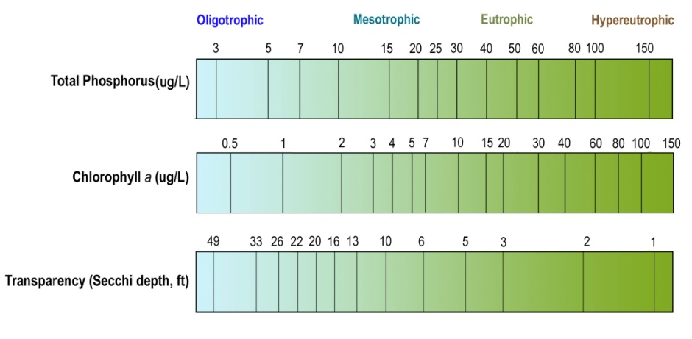
Chlorophyll-a Mean (ug/L): | 5
Chlorophyll-a Min (ug/L): | 5
Chlorophyll-a Max (ug/L): | 5
Number of Observations: | 8
Secchi Depth Mean (ft): | 18.3
Secchi Depth Min (ft): | 12.1
Secchi Depth Max (ft): | 29.5
Number of Observations: | 8

Historical Data Summary

Monitoring Program | Laboratory | Years
Citizen Lake Monitoring Program | - | 1999-2015
Water Quality Inventory of Itasca County Lakes | Itasca Community College & NE Technical Services, Inc. | 2010-2011
Lake Monitoring Program | - | 2000
Wabana Chain of Lakes | Itasca Community College | 2010, 2014
Wabana Chain of Lakes | Instrumental Research | 2005, 2008
Wabana Chain of Lakes | MN Chippewa Tribe | 1999, 2003

