Little Trout Lake Itasca County

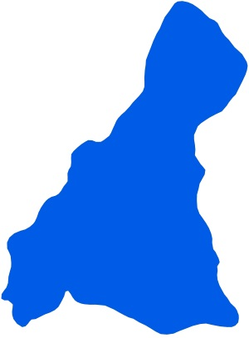
Summary
Little Trout Lake is located 20.3 miles southeast of Suomi, MN in Itasca County. It is a small lake covering 86 acres. There is no evidence of a transparency trend.

Little Trout Lake has one inlet and one outlet, which classify it as a drainage lake. Water enters Little Trout Lake from a stream on the west side and exits from a stream on the east of Little Trout Lake and carries water south to the Mississippi River.

Water quality data have been collected on Little Trout Lake from 1988-2015 (Tables 2 & 3). These data show that the lake is Oligotrophic (TSI = 37) with moderately clear water conditions most of the summer and excellent recreational opportunities.

Little Trout Lake is part of the Wabana Chain of Lakes Association (WCOLA). The association is involved in activities such as water quality monitoring and education.

Lake Vitals |  | Long-term Trends
MN Lake ID: | 31-0394-00 | Recommend minimum of 8-10 years of data with 4+ readings per season. Minimum confidence accepted by MPCA is 90%
Ecoregion: | Northern Lakes and Forests
Major Watershed: | Mississippi R. –Grand Rapids
Surface area | 86 acres
% Littoral area: | NA% | Phosphorus: Insufficient Data (1988, 1991, 1999, 2003, 2005, 2008, 2010, 2014)
Max depth: | 80 (ft) 24 (m) | Chlorophyll-a: Insufficient Data (1988, 1991, 2014)
Aquatic Invasive Species: | None | Secchi Depth: No Trend (1992-2001, 2004-2015)

Water Quality Characteristics

Parameters | Site  202 |  | Trophic State Index
Total Phosphorus Mean (ug/L): | 11.7 |  | Trophic State: Oligotrophic (37)
Total Phosphorus Min (ug/L): | <5 |  | The figure below shows the minimum and maximum values with the arrows and the mean with the black dot.
Total Phosphorus Max (ug/L): | 22
Number of Observations: | 32 | 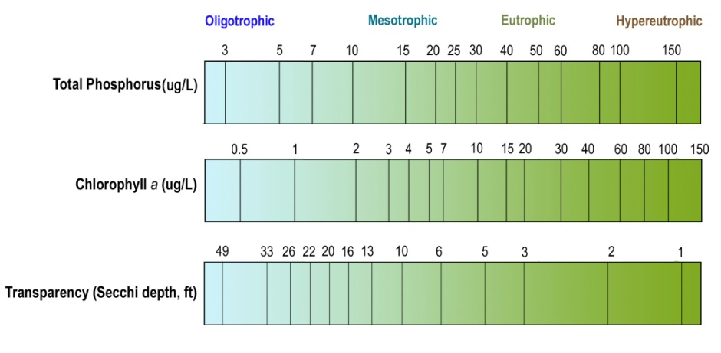
Chlorophyll-a Mean (ug/L): | 2.1
Chlorophyll-a Min (ug/L): | <1
Chlorophyll-a Max (ug/L): | 7.1
Number of Observations: | 26
Secchi Depth Mean (ft): | 20.1
Secchi Depth Min (ft): | 14.0
Secchi Depth Max (ft): | 26.0
Number of Observations: | 109

Historical Data Summary

Monitoring Program | Laboratory | Years
Citizen Lake Monitoring Program | - | 1988, 1990, 1992-2001, 2004-2015
MPCA Lake Monitoring Program Project | - | 1988, 1991
Wabana Chain of Lakes | Itasca Community College | 2010, 2014
Wabana Chain of Lakes | Instrumental Research | 2005, 2008
Wabana Chain of Lakes | MN Chippewa Tribe | 1999, 2003

