Bluewater Lake Itasca County

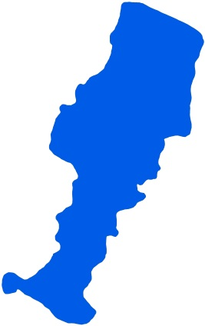
Summary
Bluewater Lake is located 16 miles southeast of Suomi, MN in Itasca County. It is part of the Wabana Chain of Lakes Association (WCOLA). WCOLA is involved in many projects including water quality monitoring and education.

Bluewater Lake has no inlets and one outlet, which classify it as a groundwater drainage lake. Water exits Bluewater Lake from Wabana Creek on the south side of the Lake and carries water south to the Mississippi River.

Water quality data have been collected on Bluewater Lake from 1988-2015 (Tables 2 & 3). These data show that the lake is oligotrophic (TSI = 36) with very clear water conditions most of the summer and excellent recreational opportunities.

Lake Vitals |  | Long-term Trends
MN Lake ID: | 31-0395-00 | Recommend minimum of 8-10 years of data with 4+ readings per season. Minimum confidence accepted by MPCA is 90%
Ecoregion: | Northern Lakes and Forests
Major Watershed: | Mississippi R. –Grand Rapids
Surface area | 359 acres
% Littoral area: | 21% | Phosphorus: No Trend (1999, 2003, 2010-2011, 2014-2015)
Max depth: | 120 (ft) 37 (m) | Chlorophyll-a: No Trend (1999, 2003, 2010-2011, 2014-2015)
Aquatic Invasive Species: | None | Secchi Depth: No Trend (1992-2016)

Water Quality Characteristics

Parameters | Site  202 |  | Trophic State Index
Total Phosphorus Mean (ug/L): | 9.4 |  | Trophic State: Oligotrophic (36)
Total Phosphorus Min (ug/L): | 4 |  | The figure below shows the minimum and maximum values with the arrows and the mean with the black dot.
Total Phosphorus Max (ug/L): | 18
Number of Observations: | 26 | 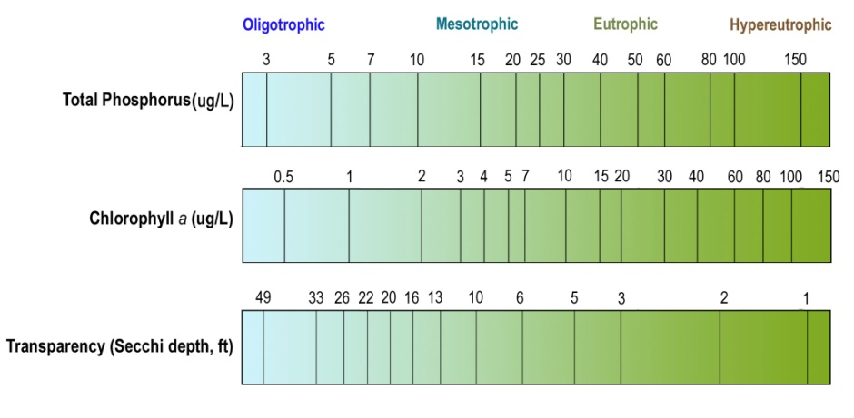
Chlorophyll-a Mean (ug/L): | 1.4
Chlorophyll-a Min (ug/L): | 1
Chlorophyll-a Max (ug/L): | 2
Number of Observations: | 4
Secchi Depth Mean (ft): | 18.9
Secchi Depth Min (ft): | 11.3
Secchi Depth Max (ft): | 27
Number of Observations: | 657

Historical Data Summary

Monitoring Program | Laboratory | Years
Citizen Lake Monitoring Program | - | 1988-2016
Clean Water Legacy Surface Water Monitoring | - | 2015
MPCA Lake Monitoring Program Project | - | 1988, 1991
Lake Monitoring Program | - | 2000
Itasca County Lake Assessment (+JLCWP) | - | 2001-2002
Paleo Lakes | - | 2001-2002
Bigfork River Watershed Priority Waters Assessment | Natural Resource Research Institute | 2001-2002
WCOLA | Itasca Community College | 2010-2011, 2014

